Diels Alder Reaction in Water

**Reference:** Handout; Chemistry lessons: Diels Alder reaction, solvent effects on reaction rate; Green lessons: alternative solvents, atom economy

**Purpose:** To understand Diels Alder reactions and how they work with a green solvent to improve the reaction

**Table of Reagents:**

|  |  |  |  |  |  |
| --- | --- | --- | --- | --- | --- |
| **Reagents** | **MW** | **Amount** | **BP (°C)** | **MP (°C)** | **Density** |
| Anthracene-9-methanol | 208.26 g/mol | 0.065 g | 423.4 °C | 163 °C | 1.214 g/cm3 |
| N-methylmaleimide | 111.1 g/mol | 0.104 g | 194.1 °C | 195 °C | 1.29 g/cm3 |
| Product (Diels-Alder) | 319.36 g/mol |  | - | - | - |

**Balanced Chemical Equation:**

* **Diels-Alder:**

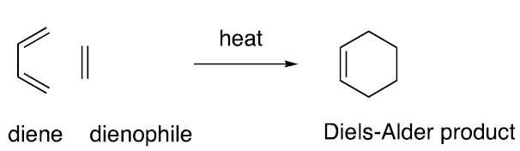

* **Reaction:**

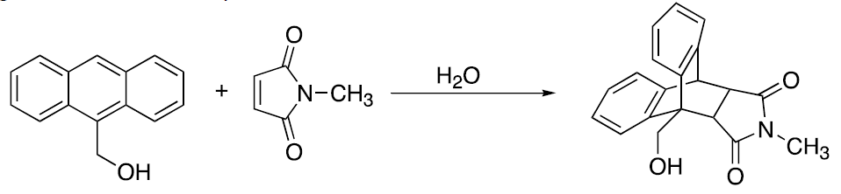

**Safety:**

* N-methylmaleimide is corrosive; Handle with care

|  |  |
| --- | --- |
| **Experimental Procedures** | **Data & Observations** |
| **1.** Obtain a 100 mL round-bottom flask; Add 0.065 g anthracene-9-methanol and 50 mL of water with a stir bar | *Anthracene-9-methanol:* 1.7455 g |
| **2.** Add 3 equivalents of N-methylmaleide to the flask. Fit the flask with condenser, heat reaction to reflux and let reaction reflux for 1 hour and stir |  |
| **3.** Monitor reaction with TLC. Develop chromatograph in 1:1 ethyl acetate: hexane. Let water evaporate before reaction/developing |  |
| **4.** Once hour done 🡪 remove flask from heat and cool to room temperature. Chill flask in ice and collect crystals. Record melting point and calculate % yield | *Mass of Product:* 0.0223 g  *Melting Point:* 228.6 °C |

**Post-lab Questions:**

**1.** We collected 0.0223 g of the Diels-Alder product as well as the color of our product was Yellowish-White.

$$\% Yield= \frac{Product Obtained}{Theoretical Yield}×100$$

*Obtained:* 0.0223 g *Color:* Yellowish-White

Limiting Reagent

* First, we must obtain the theoretical value of our Diels-Alder Product in grams:

$$0.065 g Antharacene_9_Methanol×\frac{1 mol Anth_9_Metha}{208.26 g Anth_9_Metha}= 3.12×{10}^{-4}mol Anthracene$$

$3.12×{10}^{-4} mol Anthracene×\frac{319.36 g DielsAlder Product}{1 mol DielsAlder Product}$ = .0996 g

* Next, we must use equation above to get our % Yield:
$$\% Yield=\frac{0.0223 g}{0.0996 g}×100=22.39\% yield$$

* *We received a 22.39% yield for our product*

**2.** Our crude product melted at 228.6 °C, which concludes that it contains impurites as it has experienced melting point depression. The true melting point range of the pure Diels-Alder product was recorded to be between 237 – 239 °C, whereas our product melted below the range. On the same note, this proves that our product’s crystalline structure was disrupted by impuritues, which lowered our thought to be pure product’s melting point.

**3.** Arrow-pushing mechanism for the Diels Alder reaction

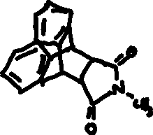

**4.** Anthracene is a viable diene as each individual ring is not well stabilized as this is a result of its number of rings spreading the electrons out. In addition, when comparing to Benzene where the ring is isolated, anthracene is reactive due to its instability and wanting to react, in comparison to Benzene not wanting to react due to its aromaticity and not wanting to break it.

**5.** The “hydrophobic effect” is essentially the tendency of nonpolar molecules to aggregate in a water solution. This means that water molecules are essentially segregated resulting in the hydrogen bonds being maximed, while the nonpolar molecules clump together to minimize the contact in water. In the experiment, Anthracene and N-Maleimide both carry the organic C-H bond which results in them clumping together. However, these two reactants also include the polar molecule of “oxygen (O)” which are more attracted to the water. The addition of these two reactants makes the nonpolar organic compounds aggregate, resulting in a reduction in the exposure to water. The hydrogen bonding between the water molecules is much stronger than the interaction between the nonpolar molecules due to that the hydrogen bonds has a dipole-dipole interaction.

**6.**

**a)** Atom Economy 🡪 Water: catalyst

$Atom Economy= \frac{MW of products}{MW of reactants}×100$

$Atom Economy= \frac{319.36 g}{(208.26+111.1)}×100= 100\%$

**b)** E-Factor

$E_{Factor}= \frac{Mass of Waste}{Mass of Product}= \frac{[\left(0.065 g+0.104 g\right)-0.0223 g]}{0.0223 g}=6.578$